How to install Maven on windows

You can download and install maven on windows, linux and MAC OS platforms. Here, we are going to learn how to install maven on windows OS.

To install maven on windows, you need to perform following steps:

1. Download maven and extract it
2. Add JAVA_HOME and MAVEN_HOME in environment variable
3. Add maven path in environment variable
4. Verify Maven

Download from the below link:

<https://maven.apache.org/download.cgi>

## 1) Download Maven

To install maven on windows, you need to download apache maven first.

Download Maven latest Maven software from [Download latest version of Maven](https://maven.apache.org/download.cgi)

For example: **apache-maven-3.8.3-bin.zip**

Extract it. Now it will look like this:

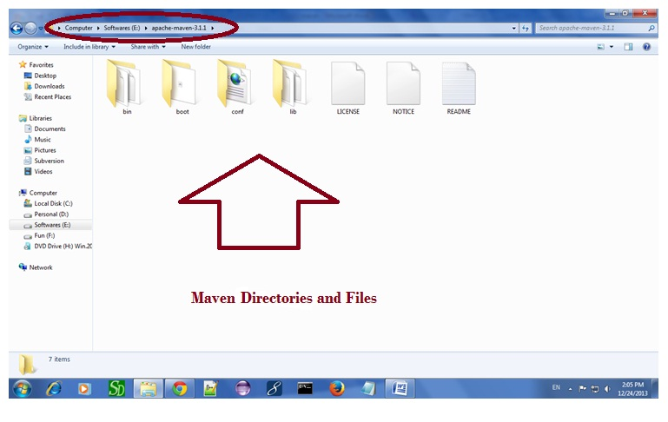

## 2) Add MAVEN_HOME in environment variable

Right click on **MyComputer** -> **properties** -> **Advanced System Settings** -> **Environment variables** -> **click new button**

Now **add MAVEN_HOME** in variable name and path of maven in variable value. It must be the home directory of maven i.e. outer directory of bin. For example: **E:\apache-maven-3.1.1** .It is displayed below:

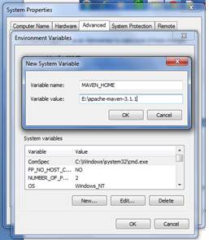

Now click on **OK** button.

## 3) Add Maven Path in environment variable

Click on new tab if path is not set, then set the path of maven. If it is set, edit the path and append the path of maven.

Here, we have installed JDK and its path is set by default, so we are going to append the path of maven.

The path of maven should be **%maven home%/bin**. For example, **E:\apache-maven-3.1.1\bin** .

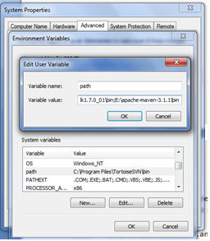

## 4)Verify maven

To verify whether maven is installed or not, open the command prompt and write:

1. mvn −version

Now it will display the version of maven and jdk including the maven home and java home.

Let's see the output:

